
Green University of Bangladesh
Department of Computer Science and Engineering (CSE)
Faculty of Sciences and Engineering
Semester: (Fall, Year: 2025), B.Sc. in CSE (Day)

Lab Report NO: 02
Course Title: Microprocessors, Microcontrollers, and Embedded System Lab
Course Code: CSE 304
Section: 232-D1

Lab Experiment Name: Implementation of conditional statement using assembly language

Student Details

Name |  | ID
1. | Ashab Uddin | 232002274

Lab Date : 22/10/2025
Submission Date : 29/10/2025
Course Teacher’s Name : Jarin Tasnim Tonvi

Lab Report Status
Marks: ………………………………… Signature: .....................
Comments: .............................................. Date: ..............................

TITLE: Implementation of conditional statement using assembly language.
1. INTRODUCTION
This lab focuses on implementing conditional statements in assembly language to understand how microprocessors make decisions based on flag registers. Unlike high-level languages that use simple if–else constructs, assembly requires explicit handling of status flags and jump instructions (such as JE, JNE, JG, etc.) to control program flow. Through practical exercises, this lab helps students grasp conditional branching, logical comparisons, and execution control at the hardware level.

2. OBJECTIVES
- To understand the concept of conditional branching and flag register operations in assembly language.
- To implement if, if–else, and case structures using conditional and unconditional jump instructions.
- assembly language. To write optimized and efficient 16-bit code.

3. PROCEDURE

Problem-1: Find out the largest number between two numbers using assembly language.

1. The program first displays a message asking the user to enter the first number (0–9).
2. It reads the input as an ASCII character and converts it to a numeric value by subtracting 30H, then stores it in register BL.
3. It prompts for the second number, reads it, converts it similarly, and stores it in BH.
4. The two numbers (BL and BH) are compared using the CMP instruction.
- If both are equal → it displays “Both numbers are equal”.
- If the first number is greater → it displays “The largest number is:” followed by the first number.
- Otherwise, it displays the second number as the largest.
5. The result is printed using INT 21H (AH = 9) and INT 21H (AH = 2) for text and character display.
6. Finally, the program exits using INT 21H (AH = 4CH).

Problem-2: Take a number input from user, check whether the given number is divisible by 5 or not.
Input:
- The program prompts the user to enter a single-digit number (0–9).
- The entered ASCII character is read through INT 21H (AH = 1) and converted into its numeric value by subtracting 30H.
- This numeric value is stored in register AL.
Calculation:
- The value in AL is divided by 5 using the DIV BL instruction, where BL = 5.
- After division, the remainder is automatically stored in register AH.
- If the remainder (AH) = 0, the number is exactly divisible by 5; otherwise, it is not divisible.
Decision & Output:
- The program compares AH with 0 using the CMP instruction.
- If equal, it displays the message “Divisible by 5.”
- If not equal, it displays “Not divisible by 5.”
- The message is printed to the console using INT 21H (AH = 9) with the corresponding string offset in DX.
4. IMPLEMENTATION
Problem-1: Source Code:

.MODEL SMALL
.STACK 100H

.DATA
STR1 DB 'Enter first number (0-9): $'
STR2 DB 0DH,0AH, 'Enter second number (0-9): $'
STR3 DB 0DH,0AH, 'The largest number is: $'
STR4 DB 0DH,0AH, 'Both numbers are equal: $'
NL DB 0DH,0AH,'$'

.CODE
MAIN PROC
; init DS
MOV AX, @DATA
MOV DS, AX

; ----- Read first digit -----
MOV DX, OFFSET STR1
MOV AH, 9
INT 21H

READ_FIRST:
MOV AH, 1 ; read char
INT 21H
CMP AL, '0'
JB READ_FIRST ; not a digit, read again
CMP AL, '9'
JA READ_FIRST ; not a digit, read again
SUB AL, '0' ; ASCII -> value 0..9
MOV BL, AL ; BL = first number

; newline
MOV DX, OFFSET NL
MOV AH, 9
INT 21H

; ----- Read second digit -----
MOV DX, OFFSET STR2
MOV AH, 9
INT 21H

READ_SECOND:
MOV AH, 1
INT 21H
CMP AL, '0'
JB READ_SECOND
CMP AL, '9'
JA READ_SECOND
SUB AL, '0'
MOV BH, AL ; BH = second number

; newline
MOV DX, OFFSET NL
MOV AH, 9
INT 21H

; ----- Compare and print result -----
CMP BL, BH
JE EQUAL_CASE
JG FIRST_IS_LARGER

; BH is larger
MOV DX, OFFSET STR3
MOV AH, 9
INT 21H

MOV DL, BH ; value 0..9
ADD DL, '0' ; to ASCII
MOV AH, 2
INT 21H
JMP DONE

FIRST_IS_LARGER:
MOV DX, OFFSET STR3
MOV AH, 9
INT 21H

MOV DL, BL
ADD DL, '0'
MOV AH, 2
INT 21H
JMP DONE

EQUAL_CASE:
MOV DX, OFFSET STR4
MOV AH, 9
INT 21H

MOV DL, BL
ADD DL, '0'
MOV AH, 2
INT 21H

DONE:
; final newline
MOV DX, OFFSET NL
MOV AH, 9
INT 21H

; exit
MOV AH, 4CH
INT 21H
MAIN ENDP
END MAIN

Problem-2 Source Code:

.MODEL SMALL
.STACK 100H

.DATA
STR1 DB 'Enter a number (0-9): $'
STR2 DB 0DH,0AH,'The number is divisible by 5.$'
STR3 DB 0DH,0AH,'The number is NOT divisible by 5.$'

.CODE
MAIN PROC
; Initialize DS
MOV AX, @DATA
MOV DS, AX

; Ask for input
MOV DX, OFFSET STR1
MOV AH, 9
INT 21H

; Read one character (digit)
MOV AH, 1
INT 21H
SUB AL, 30H ; Convert ASCII to number 0–9

; Divide the number by 5
MOV AH, 0
MOV BL, 5
DIV BL ; AL = quotient, AH = remainder

; Check remainder
CMP AH, 0
JE DIVISIBLE
JNE NOT_DIVISIBLE

DIVISIBLE:
MOV DX, OFFSET STR2
MOV AH, 9
INT 21H
JMP EXIT

NOT_DIVISIBLE:
MOV DX, OFFSET STR3
MOV AH, 9
INT 21H

EXIT:
MOV AH, 4CH
INT 21H

MAIN ENDP
END MAIN

5. OUTPUT

Output Problem-1

Step-1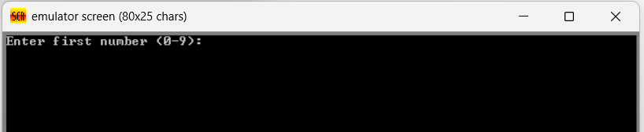
Step-2
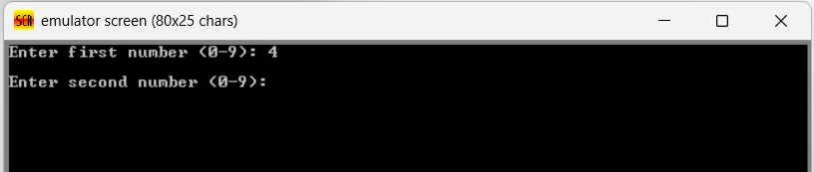
Final Step
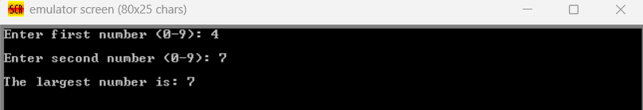

Output Problem-2

Step-1
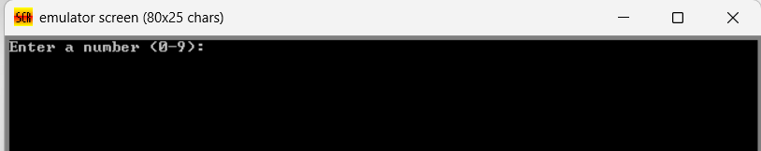
Step-2
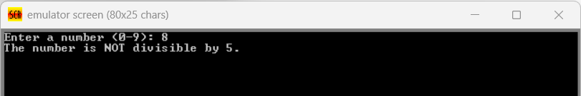
Step-3
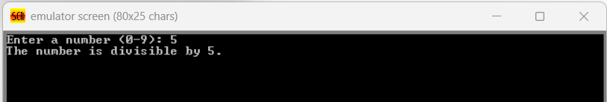

6. ANALYSIS AND DISCUSSION
This lab focuses on two conditional problems in assembly language: identifying the larger of two numbers and checking whether a number is divisible by 5. In both cases, the logic depends on flag registers and conditional jump instructions. For the first problem, the program compares two inputs using the CMP instruction and uses conditional jumps like JAE or JB to determine and display the greater value. For the second problem, the DIV instruction divides the input number by 5, and the remainder stored in the AH register determines divisibility if the remainder is zero, the number is divisible by 5.
These exercises strengthened the understanding of decision-making at the machine level. By implementing comparisons and conditional branching manually, it became clearer how high-level logic like if–else operates internally through flag manipulation. Overall, the lab enhanced practical skills in assembly programming, arithmetic operation handling, and logical control flow within the processor.

.

